Reagents
PBS-CM pH 8.0 • 2.5ml/well + 1.5ml/condition
- Add 1mM MgCl₂ and 0.1mM CaCl₂ to standard 1X PBS;
- Adjust to pH 8.0 with NaOH using a pH meter;
- Store at 4°c.

Biotinylation Solution • 1.1ml/well
- Dissolve 0.5mg/ml NHS-SS-Biotin (Pierce/Thermo Scientific 21331) in ice cold PBS-CM. Prepare this immediately before use using a pipette to stir/dissolve. Do not vortex.

Quenching Buffer • 500μl/well
- Add 20mM glycine to PBS-CM.

Lysis Buffer • 6ml/condition + 3ml • Make this fresh every time!
- 1 cOmplete™ tablet/10ml PBS-CM (Roche 11836170001);
- 1% IGEPAL-CA630 (Sigma I8896);
- 1mM PMSF (Sigma 93482).
SDS Sample Buffer (5X)
- 250mM Tris-HCL (pH 6.8);
- 10% SDS;
- 50% glycerol;
- 5% β-mercaptoethanol;
- 72.5mM EDTA;
- 0.1% bromophenol blue.
.

Day 1 • Procedure
- Rinse cells with 750μl/well ice-cold PBS-CM and then aspirate with a P1000 pipette;
- Incubate the cells with 1ml/well Biotinylation Solution for 30min in the 4°c walk-in fridge and aspirate;
- Rinse cells with 750μl/well ice-cold PBS-CM and aspirate;
- Add 1ml/well Quenching Buffer and incubate for seven minutes, then aspirate. Perform this step twice;
- Rinse cells with 750μl/well ice-cold PBS-CM and aspirate;
- Aspirate one well per condition, add 500μl ice-cold PBS-CM and use a plastic scraper (Fisherbrand 08100240) to detach the cells from the well. Make sure to be thorough and aggressive with scraping to collect as much of the cellular material as possible. For primary hippocampal cultures, protein levels are typically low and so it is advised that at least three wells of a 6-well plate are combined per condition. To any additional wells per condition, aspirate the PBS-CM rinse from step 5 and transfer the 500μl of PBS-CM from the scraped well into the new well and then use the same cell scraper on the new well. Repeat this step for as many wells per condition as deemed appropriate for your experiment. Once finished, wash the wells with 200μl ice-cold PBS-CM and collect the cells into one Eppendorf tube per condition. Spin down the samples at 500 x g (or rcf) for 5 minutes at 4°c.
- Remove the supernatant and add 200-300μl lysis buffer to the pellet. Vortex the tube to break up the pellet and then let it sit on ice for 10 minutes before running each sample through a 26 ½ gauge syringe. Lastly, nutate at 4°c for 30 minutes and then clear the cell lysate at 16,000 x g (or rcf) for 30min at 4°c;
- Transfer the supernatant for each condition to a new tube and quantify protein concentration using a BCA or Bradford assay kit (Pierce/Thermo Scientific 23227);
- Collect 5-10μg of protein from each condition for your whole cell lysate fraction into an Eppendorf tube and add 2X SDS-sample buffer containing 10% BME. Vortex the mixture and then spin down for 1 minute at high speed at room temperature. Boil the samples for 5 minutes at 95°c using the heatblock and then place in a -20°c freezer until needed;
- Use your lowest concentration condition to calculate the maximum protein quantity you can use from the remaining lysates and yet keep them equal. However, the beads used in this step are easily saturated and if you are looking to detect subtle differences in surface protein amounts, 40-50μg protein per condition is recommended, though one could start using high protein amounts and then try reducing it if needed. Pre-wash 50μl/condition of a 50% slurry of Neutravidin-conjugated agarose beads (Thermo Scientific 29200) by adding 500μl of lysis buffer and spinning down by centrifugation for 1 minute at 12,000 rpm. Then remove the supernatant carefully with a P1000 pipette. Perform this wash a total of three times and then add 50μl lysis buffer to the beads to remake the 50% slurry. Add your equal protein amounts to 50μl/condition of your pre-washed beads. Top up each condition to 500μl with lysis buffer to facilitate mixing of the beads and then place on a nutator at 4°c overnight. If you are planning to run the western the next day, place 1X Transfer Buffer in the 4°c walk-in and fill the ice pack with water and place it in the freezer.

Day 2 • Procedure
- Pellet the beads by centrifugation at 500 x g (or rcf) for 3 minutes – do not exceed 500 x g! Remove the supernatant and wash the beads 7 times with 0.5ml/wash of ice-cold lysis buffer. Between each wash, pellet the beads by centrifugation at 0.5 x g (or rcf) for 3 minutes. Remove the final wash with a P1000, then dry the beads with a P20 pipette tipped with a P2 pipette tip. Place the P2 tip at the bottom of the tube and quickly take up the remaining buffer without taking up too many beads;
- Elute 40μl SDS-sample buffer containing 100mM DTT to each tube. Boil the samples at 80°c using the heatblock for 10 minutes (note: the desired time and temperature may differ depending on the target protein) and then incubate at room temperature for 60 minutes. Remember to remove your whole cell lysates from the freezer to defrost. Spin down at 16,000 x g (or rcf) for 2 minutes and transfer the mixture to a new tube;
- Run your samples on SDS-PAGE.

Using a BCA Protein Assay Kit
- Prepare the following diluted albumin (BSA) standards:
Vial | Volume of Lysis Buffer | Volume and Source of BSA | Final BSA Concentration
A | 0μl | 300μl of BSA stock | 2,000μg/ml
B | 125μl | 375μl of BSA stock | 1,500μg/ml
C | 325μl | 325μl of BSA stock | 1,000μg/ml
D | 175μl | 175μl of Vial B dilution | 750μg/ml
E | 325μl | 325μl of Vial C dilution | 500μg/ml
F | 325μl | 325μl of Vial E dilution | 250μg/ml
G | 325μl | 325μl of Vial F dilution | 125μg/ml
H | 400μl | 100μl of Vial G dilution | 25μg/ml
I | 400μl | 0μl | 0μg/ml
- Prepare your BCA working reagent (WR) using the following calculation to determine the final volume required:
(9 + number of samples) x (number of replicates) x 250μl = final WR volume in μl
Once you have determined your final volume, prepare your WR by mixing 50 parts of BCA Reagent A with 1 part of BCA Reagent B (50:1, Reagent A:B);
- Into a microplate, load 25μl of each standard and sample replicate into a well. Perform each assessment in duplicate. Add 200μl of the WR to each well and swirl the plate thoroughly for 30 seconds;
- Cover the plate with parafilm and incubate at 37°c for 30 minutes (in the mechanical convection incubator);
- Cool the plate to room temperature;
- Measure the absorbance at 562nm on a plate reader. The plate reader we use is located in Room 3.340. Turn the plate reader on and secure your plate inside. Open KC4 (which can be found on the desktop) and load the protocol “C:\Documents and Settings\Guest\My Documents\Bamji\Jordan_BCA_duplicate.prt”. Once you have loaded the correct protocol, click the Wizard button. A prompt screen will appear containing three more buttons. Click ‘read parameters’ and check that the wavelength is set to 562nm. Return to the wizard screen and open the ‘layout’ page. Set the layout of your microplate based on how you loaded your standards/samples. Once complete, exit the wizard and click the Report button. Ensure that the program is set to report at least the plate concentrations and standard curve. Press Read and then ‘start reading’ on the prompt screen. Print your results, take out your microplate, shut down the program, turn off the plate reader and fill in an entry on the log sheet. The concentration readout is in μg/ml, which you likely need to average and convert to μg/μl.

 |  | Gel Compositions and Reagents  9% SDS-PAGE (1.5mm Resolving Gel x2)  - 5.94ml 30% Acrylamide/Bis  (Bio-Rad 161-0158)  - 5ml 1.5M Tris (pH 8.8)  - 200μl 10% SDS  - 8.76ml H₂O  - 10μl TEMED (Bio-Rad 161-0800)  - 100μl 12% APS  Running Buffer (5X)  - 15.1g Tris Base  - 72g Glycine  - 5g SDS (room temperature)  - Add MilliQ H₂O to 1L  TTBS (10X)  - 100ml 1M Tris (pH 7.4)  - 300ml 5M NaCl  - 50mL 10% Triton X-100  - Add MilliQ H₂O to 1L | Stacking (1.5mm Gel x2)  - 825μl 30% Acrylamide/Bis  - 787.5μl 1M Tris (pH 6.8)  - 62.5μl 10% SDS  - 3.75ml H₂O  - 6.25μl TEMED  - 31.25μl 12% APS  Transfer Buffer (1X)  - 6.04g Tris Base  - 28.8g Glycine  - 200ml methanol  - 1.6L ddH₂O  Final concentrations (for TTBS)  100mM Tris  1.5M NaCl  0.5% Triton X-100

Running a Western

Clean the gel plates with ethanol and wipe thoroughly. Make sure the base of the glass plates are even and aligned when placed together in the locking gate to ensure a proper seal in the apparatus. Clip the locking gate with gel plates into the BioRad setup with a grey suction pad placed beneath ensuring that the chamber between the gel plates is now properly sealed;

Prepare the resolving gel in a small beaker. Remember to add TEMED and APS last as these facilitate acrylamide polymerization and thus the setting of the gel. Ensure the mixture is thoroughly mixed by swirling;
- Use a P1000 pipette to fill the gel plate chamber with liquid resolving gel to just below the first green line (~6-7ml). Add a short but consistent layer of H₂O or isopropanol to the gel and allow it roughly one hour at room temperature to set. Note: Acrylamide is toxic and any excess used should be set using TEMED and APS before being scooped into the bin. When the excess in your beaker sets, the gel inside your chamber should also have solidified, making it a useful indicator;
- Once set, pour the H₂O or isopropanol out of the apparatus and into a KimWipe;
- Next, mix and load the stacking gel in the chamber as high as possible to the lip. Slide the comb into the gel before it sets ensuring that you introduce no bubbles. Finally, leave ~20 minutes at room temperature for the gel to set before removing the comb as steadily as possible to prevent from tearing the gel wells;
- Unclip the gel plates from the locking gate and place them into a gel holder with the shorter, thinner piece of glass facing inward. If you are running only one gel, place a buffer dam on the other side to create a sealed chamber. Place the gel holder into the running apparatus by the electrode tips and then start filling the chamber with 1X Running Buffer. Start by adding a small volume to ensure the chamber is sealed airtight. If it is not, readjust and try again. Once the chamber is full of running buffer, fill the running apparatus itself with enough running buffer for the amount of gels being run, which is marked on the side of the plastic base. It should at least be higher than the base of your gel;
- Once the running apparatus is set up, load 5μl of your standard (Precision Plus Protein Prestained Standard in Dual Color; vortex and spin down before loading) to the leftmost lane and then your samples (max 40μl) into subsequent wells. If you have performed biotinylation, load your surface fraction and then your whole cell lysate, making sure to maintain the order and keep a note of it;
- Place the lid on the running apparatus ensuring that the electrodes line up (red to red; black to black) and plug the electrodes into the power unit. Turn the unit on and set the voltage to a constant 70. Set the time to 90 minutes and hit run. Check back after ~30 minutes to see whether your proteins have reached the bottom of the stacking gel and are now being separated in the resolving gel. Once they are, stop the run and increase the voltage to 120. Leave the gel to run for at least an hour, but keep checking back until your standard is nearing the bottom of the gel and then stop the run.

Transferring
- Cut out a piece of PVDF membrane roughly the size of your gel. You can use a piece of BioRad filter paper as a size guide. Be careful not to touch the membrane with your fingers, as proteins from your hands will be transferred. Pre-rinse the membrane in MeOH to activate the PVDF, wait for it to become saturated and translucent, and pour the used MeOH back into the bottle for reuse. Rinse with distilled H₂O for ~2 minutes;
- In the 4°c walk-in, fill up a lasagna pan with pre-chilled Transfer Buffer. Also pre-soak two sponges and two Biorad filter papers per gel and leave for ~5 minutes. When the gel is ready, place it in transfer buffer also for two minutes to allow it to cool, which will cause it to shrink a little. To remove the gel from the gel plates, peel off the front panel, cut off any excess lanes and then allow it to gently fall by wiggling the back plate. If need be, snip one corner of the membrane to provide orientation;
- To create the transfer sandwich, put the membrane on top of one of the filter papers, put the gel on top of the membrane, and then place the second filter above the gel. Place this stack on one of the sponges and then put the other sponge on top. Make sure as you create your transfer sandwich that there are no air bubbles between the filter papers, which you can roll out using a serological pipette;
- Put the transfer sandwich into the sandwich holder ensuring that the gel in the stack is closer to the black side, while the membrane is closer to the white side. If this step is performed incorrectly, your protein will transfer in the wrong direction and shall be lost. Put the sandwich holder in the middle of the transfer apparatus and place the ice pack on one side closer to the black side of the sandwich holder. Place a magnetic stirrer at the bottom of the transfer reservoir and then fill it with 1X Transfer Buffer, which can partially be reused from the pan earlier. Place the apparatus on the magnetic mixer in the 4°c walk-in and turn the stir function on to keep the cool Transfer Buffer washing over the sandwich as it runs. Place the lid on, plug it into the power box and run at 100V for 1 hour or 25V overnight;
- Once complete, discard your gel and wash the setup with soap and water. Ensure that you rinse thoroughly with water once clean. Transfer your membrane to a small Tupperware container and check for protein using Ponceau S Red Stain by soaking the membrane and allowing it to sit for ~5 minutes on a tipping plate. Pour the stain back into the bottle as it can be reused and then begin washing your membrane with distilled H₂O. At first, the membrane should appear entirely pink, but as you wash it, faint bands should begin to appear. You may have to remove it from the dish and hold it against something high contrast in order to see them. Keep washing until all of the stain has gone. Make sure that the membrane remains wet at all times. If it ever dries, place it back into MeOH, then rinse with distilled H₂O;
- Block with 10ml 1X TTBS + 5% milk for 1 hour at room temperature. The blocking time and milk percentage can be adjusted depending on the antibody used and state of the blot upon exposure;
- Add primary antibody to the TTBS/milk solution. This can be saved and reused at least once more;
- Incubate at 4°c in the walk-in overnight on a rocker;
- Rinse for 10 minutes at room temperature using 1X TTBS. Perform this step a total of three times;
- Incubate the membrane in 1:3,000 of your secondary antibody for 1 hour at room temperature in 1X TTBS. This can also be saved and reused at least once more;
- Rinse for 10 minutes at room temperature using 1X TTBS. Perform this step a total of three times. Your blot is now ready for exposure/imaging, though the protocol shall depend on whether you’re using x-ray film, HRP or fluorescent secondary antibodies to visualize your protein bands.

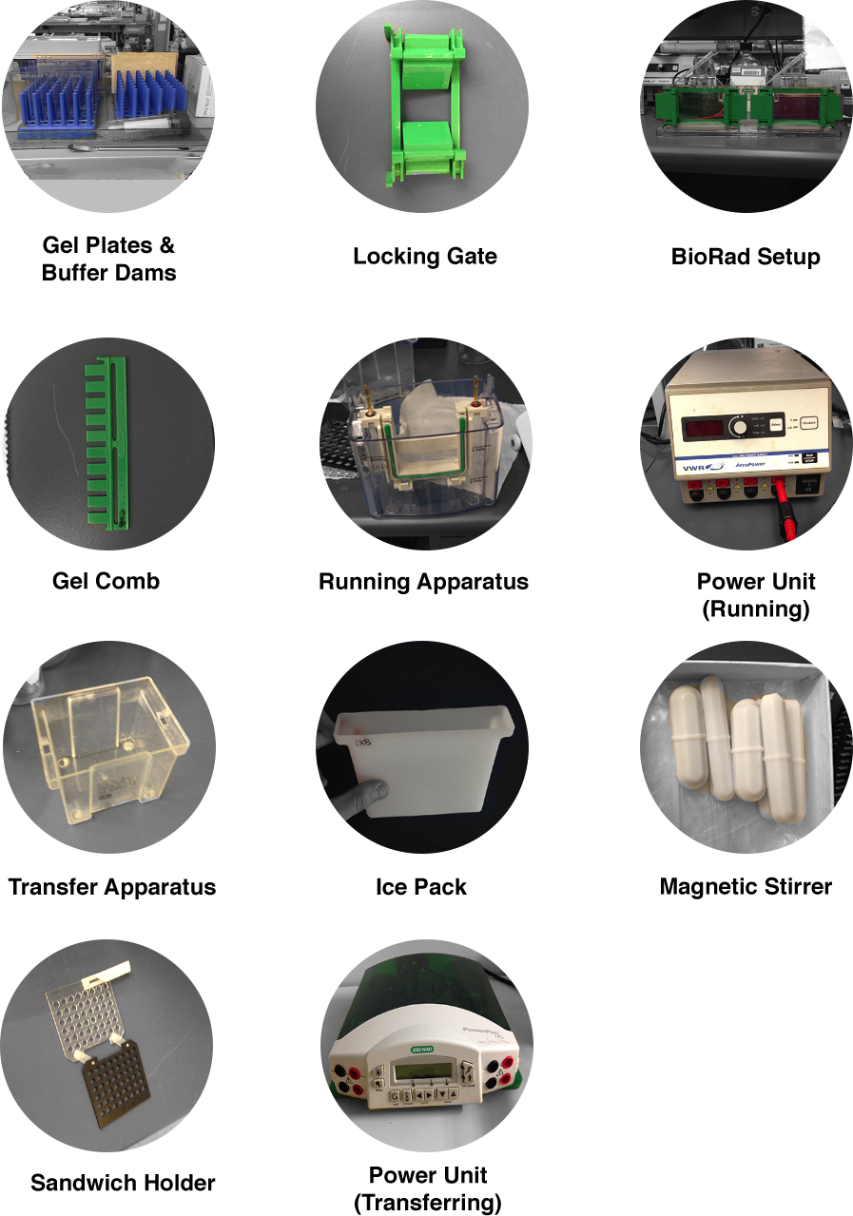
Images

…

