bamji lab chemical ltp protocol

ecs (+TTX/Str) recipe for cltp

Recipe for stock ECS
NaCl 140 mM
KCl 5 mM
CaCl₂ 1.3 mM
HEPES 25 mM
D-glucose 33 mM
pH 7.35 with NaOH, filter sterilize and store in fridge
To make ECS (+TTX/Str) add the following to ECS
TTX 0.0005 mM (add on day of exp)
Strychnine 0.001 mM (add on day of exp)
Bicuculline

important notes
- Stock ECS solution should be sterilized (vacuum filtration) and stored in fridge.
- Supplements/drugs (TTX, strychnine, Gly) should always be added fresh to the stock ECS solution on day of exp.
- Solutions should be pre-warmed before use (37°C).

Solutions for cLtp protocol
(-) Mg²⁺ ECS = ECS (+TTX/Str) no further additives
(+) Gly ECS = ECS (+TTX/Str) + 200 μM Glycine (made fresh, add on day of exp)
(+) Mg²⁺ ECS = ECS (+TTX/Str) + 2 mM Mg²⁺

getting started
- To make ECS (+TTX/Str), start by calculating how much of each of the above solutions you will need.
- Measure out the total volume of ECS for all solutions and add TTX and strychnine.
- Aliquot ECS (+TTX/Str) into 3 falcons, one for each of the 3 solutions.
- Add Gly to the (+) Gly ECS (from 200 mM stock made fresh from powder).
- Add Mg²⁺ to the (+) Mg²⁺ ECS (from 2M aliquot in freezer).
- Pre-warm all solutions to 37’C.

cLtp protocol
- Pipette off the media and save in a labelled falcon tube and store in the incubator.
- Wash the neurons with 1 ml of pre warmed (-)Mg²⁺ solution 2 times, leaving
12-well plate in the incubator for 10 minutes after second wash.
- Aspirate the (-)Mg²⁺ solution and add 1ml (+)Gly solution. Incubate the neurons with (+)Gly solution for exactly 3 minutes (in 37’C incubator).
- Wash the neurons with 1 ml of (+)Mg²⁺ solution twice and put back the saved media, until appropriate timepoint post cLTP.
- Fix or lyse the cells as needed.

How does glycine cLTP work?
Glycine cLTP enhances post-synaptic NMDAR Ca²⁺ influx. Glycine is a co-agonist at the NMDAR (along with glutamate), and when present at high concentrations increases NMDAR open probability. The resulting increased NMDAR Ca²⁺ influx triggers post-synaptic cLTP, including insertion of AMPARs. Previous studies have measured mEPSCs after glycine cLTP, and observed an increase in the frequency and amplitude of mEPSCs.
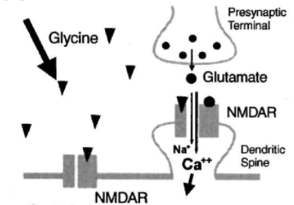
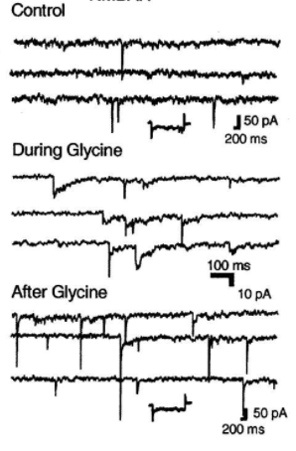
Images from Lu et al., 2001
Why do we include TTX in the solutions? TTX is an Na⁺ channel antagonist that blocks action potential firing. With action potentials blocked, neuronal activity is greatly reduced, and the only glutamate release onto neurons will be due to small spontaneous pre-synaptic vesicle fusion events at the synapses. When we add glycine, any increased NMDAR activity/calcium influx will be highly localized to synapses, making this a highly synapse specific stimulation protocol.
Why do we include strychnine in the solutions? The high concentrations of glycine used to stimulate NMDARs will also activate inhibitory glycine receptors (GlyRs). Strychnine is a GlyR antagonist, so will prevent simultaneous neuronal inhibition caused by GlyR activation.
Rationale for Step 1: Wash in Mg²⁺ free solution. This is to alleviate the Mg²⁺ block from NMDARs, which are normally blocked at resting membrane potential by physiological extracellular concentrations of Mg²⁺ (~1mM). Because we’re adding TTX which blocks action potentials, there is no way the Mg²⁺ block can be relieved, as neuronal depolarization is essentially blocked, so we have to wash out ALL of the Mg²⁺ to properly activate NMDARs during cLTP.
Rationale for Step 2: Wash in (+)Gly. 200 μM glycine should saturate all NMDAR glycine binding sites. When spontaneous glutamate release occurs, glycine will boost the NMDAR Ca²⁺ influx and induce cLTP.
Rationale for Step 3: Wash in (+)Mg. This will immediately block NMDARs and end the cLTP stimulation. This step is important to ensure that all cells receive the exact same duration of cLTP treatment (3 mins).

Read this paper for more info! https://doi.org/10.1016/S0896-6273(01)00194-5

How much of each solution do I need?
(-) Mg²⁺ ECS: Standard ECS
12 well: 1 ml wash/well for 3 washes = 3 ml/well
10cm dish: 4ml wash/dish for 3 washes = 12 ml/dish

(+) Gly ECS: Standard ECS + 200 μM Glycine (made fresh, add on day of exp)
12 well: 1 ml wash/well for 1 incubation = 1 ml/well
10cm dish: 4ml wash/dish for 1 incubation = 4 ml/dish

(+) Mg²⁺ ECS: Standard ECS + 2 mM Mg²⁺
12 well: 1 ml wash/well for 2 washes = 2 ml/well
10cm dish: 4ml wash/dish for 2 washes = 8 ml/dish

For alternative cLTP and cLTD protocols see: https://bio-protocol.org/prep410

