Plasmid Midiprep (using promega)
Preculture(~10ml) LB
Inoculation from preculture into 100ml LB
Morning--------------------------------Evening------------------------------------Next day morning
- Inoculate a colony from the agar plate in a 5-10 ml LB media (with antibiotic) in a 50ml falcon as a preculture in the morning using a pipette tip. Incubate at 37°C in a shaker
- Inoculate 1 ml of this culture into a 100ml LB + antibiotic (in a conical flask of 1000ml capacity-this large flask will ensure proper aeration for the culture). Incubate the flask at 37°C in a shaker.
- After 12-16h (next day), pellet down the cells by pouring the culture in 50ml falcons and centrifuging at 5000rpm for 10 min, RT.
- Discard the supernatant
- Add 6ml of Solution I (Cell resuspension solution) to the pellet and resuspend the pellet using a 10ml pipette. Combine the pellet from the other falcon-in case you distributed your culture volume in 2 falcons. Pool up the total resuspended culture now into oakridge tubes.
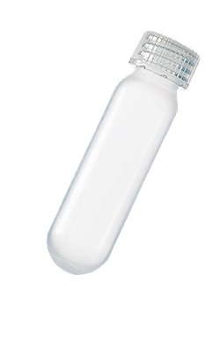
Oakridge tube
- Check whether the pellet is completely resuspended and no smaller pellets are left.
- Add 6ml of Solution II (Cell lysis solution) from the side. Mix it well by inverting slowly 5-6 times.
- Add 10ml of Solution III (Neutralization Solution) to the tube and again mix slowly by inverting the tube till you see the precipitate and the solution becomes homogenous.
- Spin @ 15,000-15,500 rpm for 20-30 min RT, in a sorvall centrifuge (upstairs, ask someone for help if you are not familiar with it-use rotor SS34).

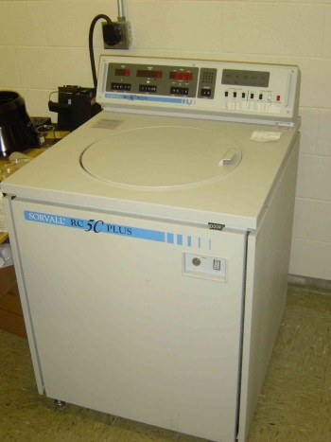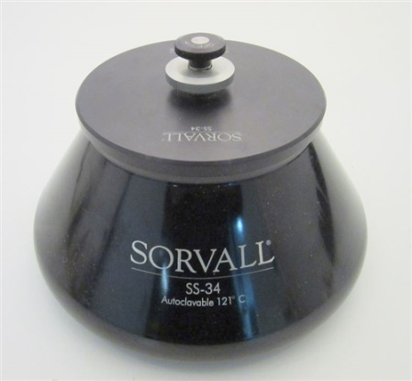
Sorvall Centrifuge; SS34 rotor

- While the tubes are being centrifuged, prepare the vacuum chamber (PROMEGA) and place the filter columns-first white and a blue filter over to that.
- Pour the supernatant over the blue filter column and allow it to pass into the white column by gravity (note: blue column is a filter column while the white one is a DNA purification column). Discard the blue column (the blue column is simply to ensure that no precipitate is left out in the white column which may create a problem during further steps)
- Use the vacuum pump upto 30 Pascals (check the indicator) to elute out the supernatant from the white column.
- Wash with 5 ml of Endotoxin removal solution.
- Once it is completely eluted out, add 20 ml of Wash buffer (check if it is supplemented with Ethanol). Drain it with vacuum.
- Run the vacuum for 1 min after draining the Ethanol; this is to completely dry the membrane column, so as to not contaminate the DNA with extra alcohol.
- Remove the white column from the Vacuum chamber and wipe the column nozzle on a kimwipe, if you happen to see some wash buffer droplets.
- Place the column on the DNA eluting chamber (blue case that holds a µfuge tube with a transparent open cap) that contains an open µfuge tube so as to elute the DNA directly into it.
- Add from 350-500µl of warm (40-45°C) nuclease free H2O (provided in the kit) onto the white column and wait for about a min.
- Switch on the vacuum pump and allow the DNA to be eluted into the µfuge tube. Try to increase the vaccum pressure to upto 50-60 pascals to ensure complete remove of the water containing DNA. Close the stopper once done, and only then switch off the pump (It is important to close the stopper before switching off the pump so as to not damage the DNA membrane in the column).
- Carefully take out the µfuge tube, close the lid and allow it to stand for 10 min.
- Spin down the tube in a centrifuge at 13,000 rpm for a min at RT to pellet down some debris or column fibres.
- Take the supernatant carefully into a new µfuge tube and measure the DNA concentration using a nanodrop.

